Project Title : AI powered Nutrition Analyzer for Fitness Enthusiasts Project Design Phase-I - Solution Fit Template Team ID: PNT2022TMID41534

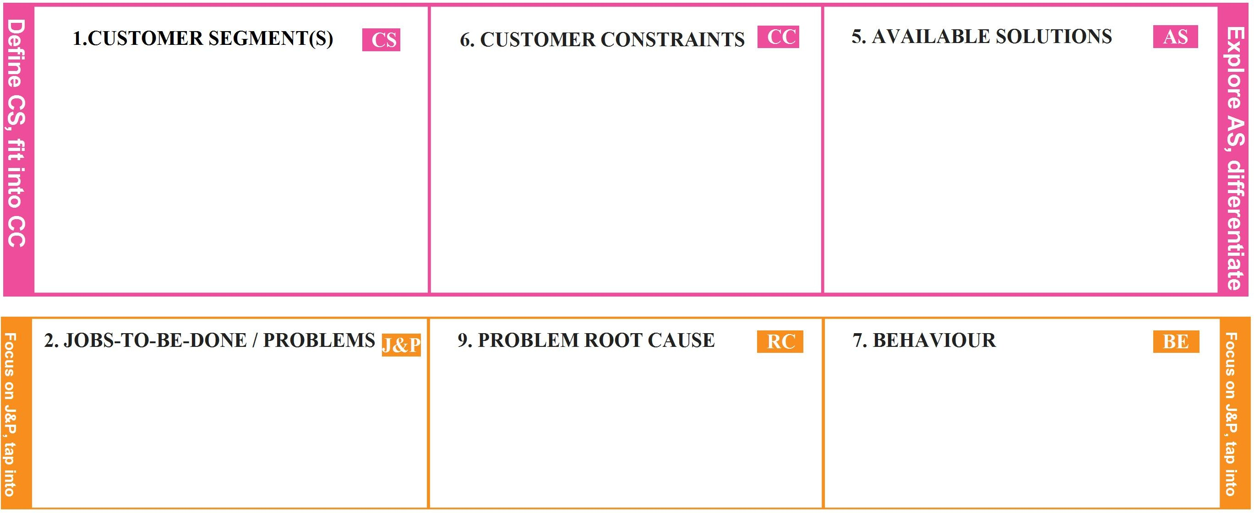

* Healthy Eaters
* Sports Persons
* Senior Citizens
* Internet Facility
* Spending Time

To detect the nutrition based on fruits like Sugar, Fibre, Protein, Calories,etc. to make the users conscious about their foods.

* Incorrect Details
* Low quality image leads to wrong prediction of nutrients

●

●

Busy Schedule Laziness

* Consulting Doctors
* Maintaining their own diet

|  |  |  |  |  |
| --- | --- | --- | --- | --- |
| **Identify TR &strong EM** | 1. **TRIGGERS TR**   Through advertisements, neighbors or through social media   1. **EMOTIONS: BEFORE / AFTER**   Before: Unhealthy,Confused After:Healthy,Confident | **10. YOUR SOLUTION** | **8.CHANNELS OF BEHAVIOUR** | **Identify TR &strong EM** |
| To track the health care plan of an individual.To track the calories in the food by uploading images.To suggests food based on their health conditions. | **ONLINE:**   * Through Social Media * Channel Advertisements   **OFFLINE:**   * Suggests neighbors * Through pamplets |